Research Findings Report after Contextual Interview
Unveiling User Behavior and Characteristics through interview Data Analysis: Insights by Sayantan Ghosh

Introduction
In pursuit of creating a thorough and data-driven analysis for an Elderly Fitness Application, UX research has been conducted through contextual interviews. The primary objective of these interviews is to glean insights into user characteristics and conduct micro-analysis accordingly. The study involved engaging with a sample of 9 elderly users.

The interviews were conducted using two distinct methods of qualitative interviews: Active Contextual Interview and Passive Contextual Interview.

Active Contextual Interview entails the researcher conducting interviews while the subjects are actively engaged in relevant activities, aligning closely with the context. Conversely, Passive Contextual Interview involves engaging with users either after or before they undertake the related activity. The active approach is preferred as it offers a more immersive and insightful interaction with users during their engagement with the application.

Challenges
One notable challenge encountered during the interview process was the reluctance of female participants to disclose aging-related or activity-related data to the researcher, leading to a disproportionate focus on male users. To address this gender disparity and gain insights into the experiences of female users, supplementary research is being conducted through online videos and articles.
Another challenge arose in persuading elderly participants to allocate more than 15 minutes of their time for the research sessions. Given that the research typically spanned between 10 to 30 minutes, extending the engagement time proved to be a significant hurdle.
Interview Protocol
The research process adhered to strict ethical guidelines, ensuring that no critical personal data or information that users were unwilling to share with the researcher was collected. Participants were assured of confidentiality and privacy throughout the interview process. The focus remained solely on gathering insights relevant to the study objectives without intruding upon the privacy or comfort of the participants.
Predefine Questions
The research process commences with a comprehensive literature review aimed at understanding the pertinent data categories and formulating relevant questions for the contextual interviews.
The interview process encompasses over 30 questions, thoughtfully distributed across six key categories:
The interview revolves around 30+ questions distributed by 6 categories.

(i) Understanding Daily Routine and Health Habits
(ii) Support System and Health Management
(iii) Motivation and Social Engagement
(iv) Psychological Factors and Satisfaction
(v) Technology Use and Health Awareness
(vi) Physical Activity Preferences

Each category is designed to elicit valuable insights into various aspects of user behavior and preferences. On average, participants are queried with approximately five questions per category, ensuring a focused and effective approach to gathering user research data.

Presenting Insights from Contextual Interviews: Visualizing Qualitative Data
The outcome data from the contextual interviews has been visually represented. Within this research, a paramount focus lies in comprehending the effects of aging and the level of health awareness among elderly users. Concurrently, the research endeavors to discern common behavioral patterns across all real-time users. The insights derived from this data are instrumental in providing clarity and identifying opportunities for UX research.

UX Research Report: Understanding Elderly Engagement in Physical Activities
Introduction
The purpose of this report is to analyze the time investment of elders in various physical activities, namely morning walks, evening walks, and yoga. Understanding how elders allocate their time towards these activities is crucial for designing user experiences that promote and support healthy lifestyle choices among this demographic.
Methodology
The data was collected through self-reporting from a sample group of 9 elders. Participants were asked to specify the duration of their morning walks, evening walks, and yoga sessions. The data was then compiled and analyzed to identify patterns and insights regarding time investment in physical activities among the elderly population.
- Findings:
X axis- Username, Y axis - Time investment by all users based on different activities.
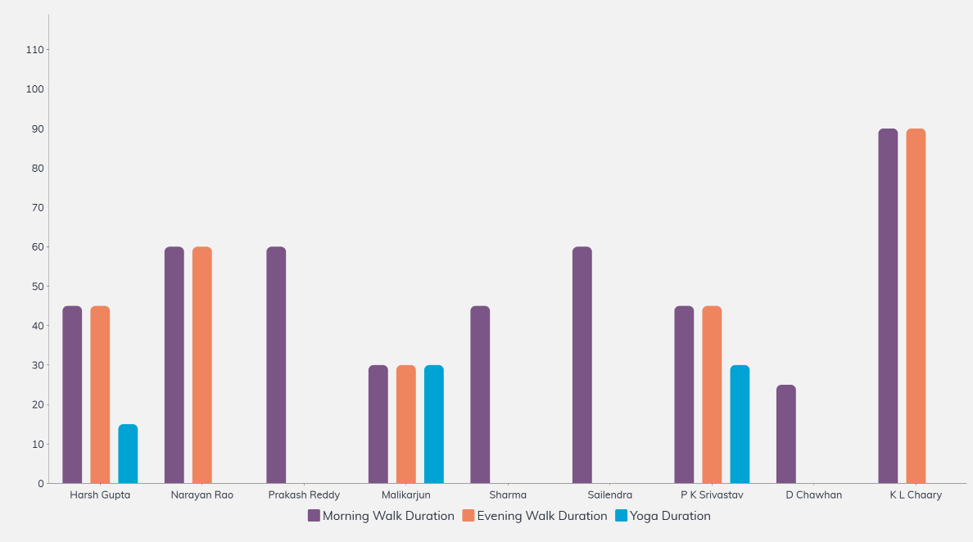
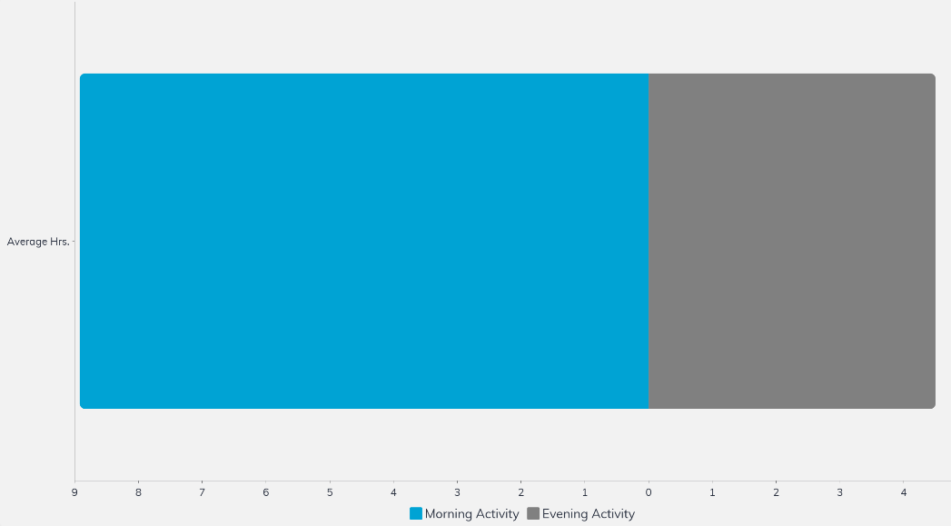
Morning Walk Duration:
The average duration of morning walks among the participants was 51 minutes.
The range of morning walk durations varied from 25 minutes to 90 minutes.
60% of the participants engaged in morning walks, with varying durations.
Evening Walk Duration:
The average duration of evening walks among the participants was 53 minutes.
The range of evening walk durations varied from 30 minutes to 90 minutes.
50% of the participants engaged in evening walks, with varying durations.
Yoga Duration:
The average duration of yoga sessions among the participants was 25 minutes.
The range of yoga durations varied from 15 minutes to 30 minutes.
40% of the participants engaged in yoga sessions, with varying durations.
Participant Engagement:
Morning walks and evening walks showed higher levels of participation compared to yoga sessions.
There were instances where participants engaged in one type of activity but not others, indicating preferences or limitations.
Variances:
Some participants had consistent engagement in all three activities, while others showed variations or gaps in their engagement.
Factors such as personal preferences, health conditions, and environmental factors may influence the variability in engagement.
- Recommendations:
Diversify Activity Offerings:
Provide a variety of physical activity options to cater to individual preferences and needs.
Offer alternatives for those who may not be able to engage in certain activities due to physical limitations.
Flexible Scheduling:
Allow for flexibility in scheduling activities to accommodate varying time commitments and preferences.
Offer both morning and evening sessions to cater to different schedules and routines.
Promote Consistency:
Encourage consistent engagement in physical activities by highlighting the health benefits and providing motivational support.
Offer incentives or rewards for regular participation to foster a sense of accountability and motivation.
Accessibility and Support:
Ensure that physical activity spaces and resources are accessible and inclusive for all elders, including those with mobility issues or other disabilities.
Provide support and guidance for those who may need assistance in initiating or maintaining physical activity routines.
Conclusion
Understanding the time investment of elders in physical activities such as morning walks, evening walks, and yoga is essential for designing effective user experiences that promote healthy aging. By recognizing individual preferences, addressing barriers to engagement, and providing support and encouragement, we can create environments that facilitate and sustain active lifestyles among the elderly population. Further research and user feedback will be valuable in refining these recommendations and tailoring interventions to meet the diverse needs of elders.
UX Research Report:Morning wake-up time
Introduction
This report presents findings from a user research study conducted to understand wakeup time preferences among a group of individuals. The study aimed to identify the distribution of wakeup times within the sample group and explore any patterns or trends in their wakeup habits.
Methodology
The data was collected through self-reported wakeup times from each participant. Participants were asked to indicate their usual wakeup time within predefined time intervals of 5 to 5:30 am, 6 to 6:30 am, and 7 to 7:30 am. The responses were recorded and analyzed to determine the distribution of wakeup times among the participants.

- Findings:
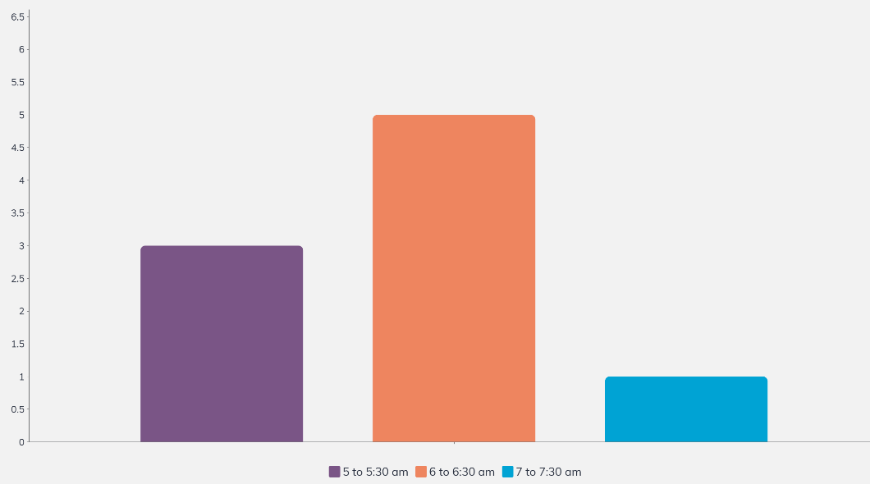
Insight:
The majority of participants prefer to wake up between 6 to 6:30 am, with 5 out of 9 participants falling into this category.
3 participants prefer to wake up earlier, between 5 to 5:30 am.
Only 1 participant prefers to wake up later, between 7 to 7:30 am.
There is variability in wakeup times among the participants, indicating individual preferences and routines.
Recommendations:
Consider offering flexible wakeup time options in programs or services catering to diverse schedules and preferences.
- Provide resources and guidance for establishing healthy morning routines, regardless of wakeup time, to promote productivity and well-being.
- Further investigate the factors influencing wakeup time preferences among different demographic groups to better tailor interventions and support mechanisms.

Conclusion
Understanding wakeup time preferences is essential for designing user experiences and services that accommodate the diverse needs of individuals. By recognizing the distribution of wakeup times and the factors influencing them, communities can better support individuals in establishing healthy morning routines and maximizing their productivity and well-being. Further research and user feedback will be valuable in refining these recommendations and developing targeted strategies to meet the unique needs of users.
UX Research Report:Detailed Report of Health Conditions of Elders
Introduction
This report presents findings on the prevalent health conditions among a sample of 9 elderly individuals. The research focuses on identifying the occurrences of various health conditions such as thyroid issues, diabetes, blood pressure concerns, heart problems, arthritis or bone injuries, and other aging-related problems.
Methodology
The data was gathered through research conducted with 9 users, who provided information about their health conditions. Participants were asked to indicate whether they had been diagnosed with specific health issues, and their responses were recorded accordingly. The occurrences of each health condition were tallied to determine the prevalence within the sample group.
- Findings:
Understanding the distributed health conditions among elders.
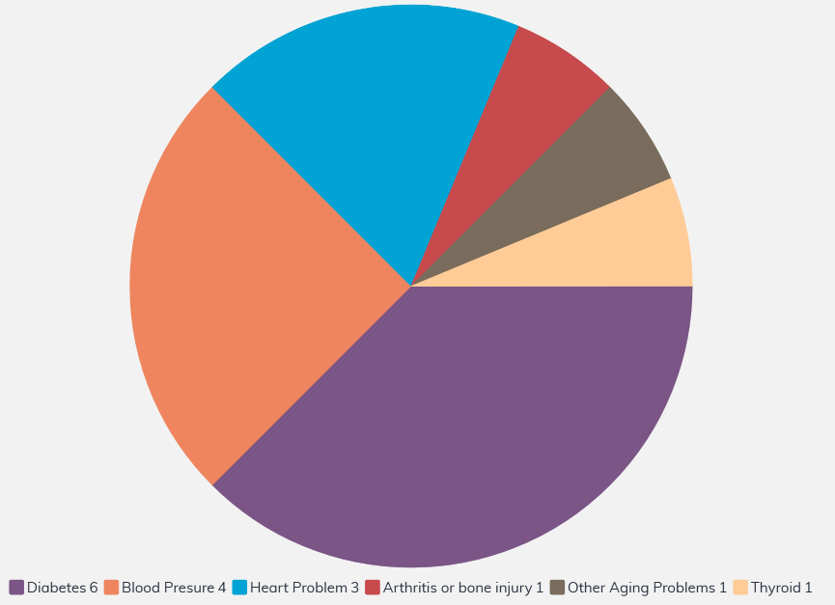
Insights:
Ensure that physical activity spaces and resources are accessible and inclusive for all elders, including those with mobility issues or other disabilities.
Diabetes is the most prevalent health condition among the sample group, with 6 out of 9 participants reporting a diagnosis.
Blood pressure concerns and heart problems are also relatively common, affecting 4 and 3 participants respectively.
Arthritis or bone injuries are not reported among the participants, suggesting either a lower prevalence of these conditions or underreporting.
Thyroid issues and other aging-related problems show lower occurrences within the sample group.
Recommendations:
Based on the findings, the following recommendations can be made:
- Encourage regular health screenings and check-ups for early detection and management of prevalent health conditions such as diabetes and blood pressure concerns.
- Provide education and resources for managing chronic conditions like diabetes and heart problems to improve overall health outcomes.
- Promote lifestyle modifications such as regular physical activity and healthy eating habits to mitigate the risk factors associated with common health conditions in the elderly population
Conclusion
Understanding the prevalent health conditions among elders is crucial for designing targeted interventions and healthcare services tailored to their needs. By addressing the specific health concerns identified in this research, communities can work towards improving the overall health and well-being of the elderly population. Further research and ongoing monitoring of health trends will be essential for implementing effective strategies to support healthy aging.
UX Research Report:Medicine Management Habits
Introduction
This report provides insights into the medicine management habits of individuals based on research conducted with a sample of 9 users. The study aimed to understand the frequency of medicine intake, reliance on reminders, and the perception of the need for medication among participants. Additionally, it explores challenges related to taking medicine before or after meals when meal times are not fixed, with the assistance of reminders.
Methodology
Data was collected through user interviews and surveys to gather information on participants' medicine management habits. Participants were asked about their frequency of medicine intake, whether they use reminders, and their perception of the need for medication. Responses were analyzed to identify patterns and trends in medicine management behaviors. Further inquiries were made regarding challenges faced in taking medicine before or after meals when meal times are not fixed, especially with the assistance of reminders.
- Findings:
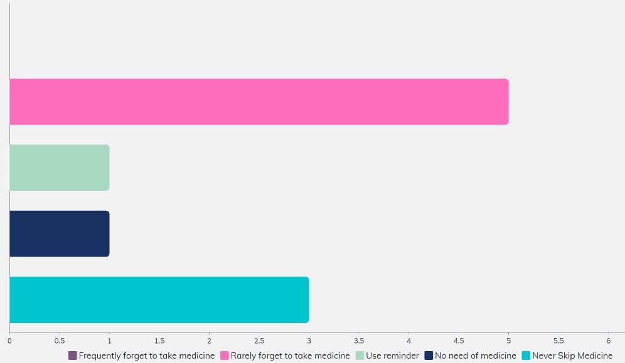
Frequency of Medicine Intake:
3 out of 9 participants reported never skipping their medicine, indicating a consistent adherence to their medication regimen.
None of the participants frequently forget to take their medicine, suggesting a high level of adherence among the sample group.
5 participants reported rarely forgetting to take their medicine, indicating occasional lapses in adherence but overall responsible medicine management practices.
Use of Reminders:
Only 1 participant reported using reminders for medicine intake, indicating a relatively low reliance on external cues for medication adherence within the sample group.
Perception of Medicine Necessity:
1 participant indicated that they have no need for medicine, suggesting either a lack of medical conditions requiring treatment or a personal belief in alternative health practices.
Challenges with Medicine Timing and Meal Times:
Some participants expressed challenges in taking medicine before or after meals when meal times are not fixed. This uncertainty can disrupt their medication routine and lead to inconsistencies in medicine intake.
For participants facing this challenge, the use of reminders has been beneficial in helping them remember to take their medicine regardless of meal timing variations.
Insights:
The majority of participants demonstrate responsible medicine management habits, with only a few reporting occasional lapses in adherence.
Challenges with medicine timing and meal times are common, particularly when
meal- times are not fixed, leading to inconsistencies in medicine intake.
Reminders play a crucial role in helping participants overcome challenges related to medicine timing and meal variations, ensuring consistent adherence to medication regimens.
- Recommendations:
Based on the findings, the following recommendations can be made:
- Provide education and support for individuals to address challenges related to medicine timing and meal variations, emphasizing the importance of consistent adherence to medication regimens.
- Develop user-friendly reminder systems or applications that allow for flexible scheduling of medicine intake, accommodating variations in meal times and daily routines.
- Offer personalized healthcare interventions to address the unique needs and challenges faced by individuals in managing their medication routines, ensuring comprehensive support for medication adherence.

Conclusion
Understanding medicine management habits and associated challenges is essential for designing effective healthcare interventions and support systems. By recognizing patterns in medication adherence and addressing individual needs and preferences, healthcare providers can enhance patient outcomes and promote overall well-being. Further research and user feedback will be valuable in refining these recommendations and developing tailored strategies to support medication adherence among diverse user groups, especially in addressing challenges related to meal timing variations.

UX Research Report:Platform and Device Usage Among 9 Sample Users
Introduction
This report presents findings on the usage and engagement levels across various platforms and devices among a sample group of 9 users. The research aimed to understand the frequency and extent of engagement on different platforms, including social media, communication platforms, online videos, banking/payment apps, and online shopping. Additionally, it explores the preference for different devices among the sample group.
Methodology
Data was collected through user surveys and interviews to gather insights into platform and device usage habits. Participants were asked to provide information about their usage patterns and frequency of interaction with each platform, as well as their preferred devices for accessing these platforms. Responses were analyzed to identify trends and preferences among the sample group.
- Findings:
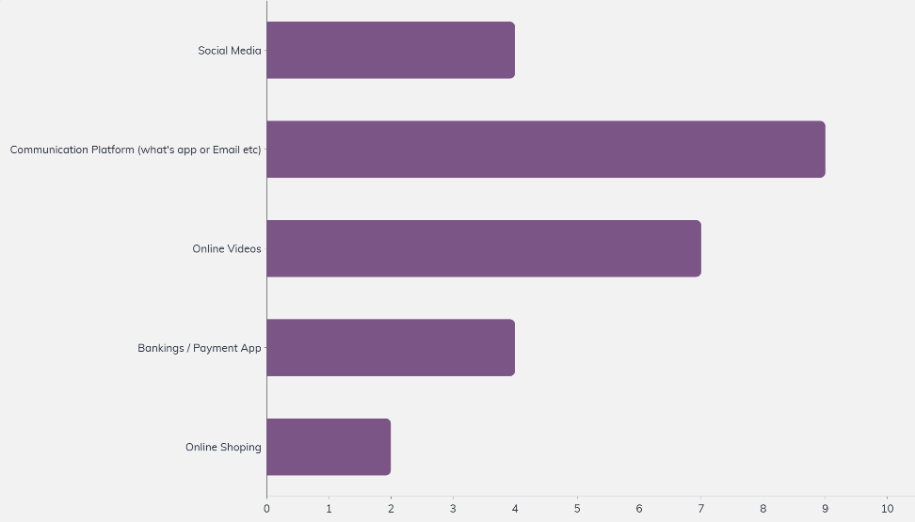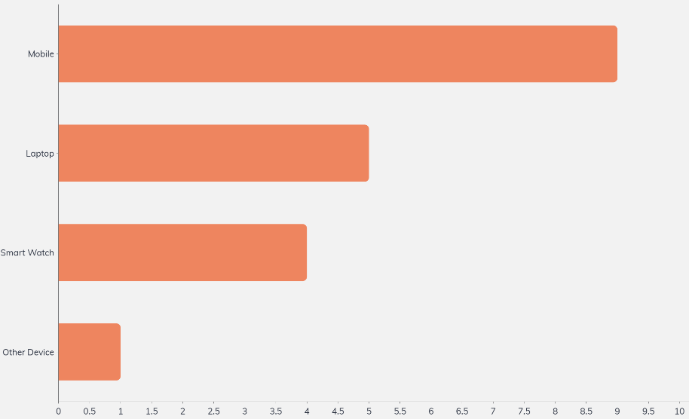
Device Preference:
Mobile: 9 out of 9 users preferred using mobile devices for accessing various platforms and services.
Laptop: 5 out of 9 users preferred using laptops for specific tasks or activities.
Smart Watch: 4 out of 9 users used smartwatches for certain interactions, indicating limited but growing usage.
Other Device: 1 out of 9 users reported using other devices, such as tablets or desktop computers, for accessing digital services.
Platform Usage:
Social Media: 4 out of 9 users reported regular engagement with social media platforms.
Communication Platform All 9 users indicated frequent engagement with communication platforms such as WhatsApp or email.
Online Videos: 7 out of 9 users reported regular engagement with online video platforms.
Banking/Payment App 4 out of 9 users reported regular engagement with banking or payment apps.
Online Shopping Only 2 out of 9 users reported regular engagement with online shopping platforms.
Insights:
Communication platforms like WhatsApp or email are universally popular among the sample group, indicating their essential role in daily interactions.
- Online video consumption is prevalent, suggesting a preference for visual content and entertainment.
- Social media engagement varies, indicating individual preferences for social interaction online.
- Banking/payment apps see moderate usage, reflecting a growing trend towards digital financial transactions.
- Online shopping platforms have lower engagement levels, suggesting potential areas for improvement or targeted marketing efforts.
- Mobile devices are the preferred choice for accessing digital platforms and services among users, highlighting the importance of mobile optimization for a seamless user experience.
- Recommendations:
Based on the findings, the following recommendations can be made
- Enhance user experiences on social media platforms to increase engagement and interaction among users.
- Invest in content creation and curation for online video platforms to cater to user preferences for visual content and entertainment.
- Improve user interfaces and functionalities of banking/payment apps to streamline financial transactions and enhance user trust.
- Implement strategies to promote online shopping platforms and incentivize users to explore and utilize e-commerce services.
- Prioritize mobile optimization to ensure a seamless user experience across different platforms and services.
Conclusion
Understanding user engagement across various platforms and devices is essential for designing effective digital experiences and services. By recognizing usage patterns and preferences, businesses and service providers can tailor their offerings to better meet the needs and expectations of their target audience. Further research and user feedback will be valuable in refining these recommendations and developing strategies to enhance user engagement and satisfaction.
Overall Understanding summary of the contextual interview
Overall, the contextual interviews provided rich qualitative data that complemented the quantitative findings, offering deeper insights into user behaviors, preferences, and pain points. These insights will inform the development of user-centric solutions and experiences tailored to meet the needs of our target audience.

